
Principles of Human Services Syllabus
2025-2026 Fall Semester
Instructor Information:
Instructor: Jane Dill e-mail: dillj@nzisd.org
Phone: 936-241-7100 Extension: 1804
Tutorial Times: After School Room #: 804
Conference Period: 6th period - 11:43-12:29
Introduction & Course Overview
This course will enable students to investigate careers in the human services career cluster, including counseling and mental health, early childhood development, family and community, and personal care services. Each student is expected to complete the knowledge and skills essential for success in high-skill, high-wage, or high-demand human services careers.
Classroom Expectations
To ensure a productive and respectful learning environment, all students are expected to:
● Be on time for class and ready to learn.
● Show respect to classmates, the instructor, and the learning space.
● Bring a charged computer or necessary technology each day. ● Complete and submit assignments on time.
Required Materials
The required materials are pens or pencils, paper, and computers. Technology Use
Students may be expected to complete a variety of activities on digital platforms such as Schoology, Microsoft Word, Microsoft PowerPoint, Kahoot, Canva, etc. To complete online coursework, students must use their district assigned laptop. Technology use is restricted to class activities ONLY to prevent additional distractions in the classroom.
North Zulch ISD
11390 Fifth Street
North Zulch, TX 77872
Principles of Human Services Syllabus
2025-2026 Fall Semester
Academic Dishonesty & Plagiarism
Our district has a zero-tolerance space for cheating and plagiarism. Any submitted work that is not your own will receive a zero as well as warrant parent contact and an office referral. This includes the use of Artificial Intelligence (AI) such as ChatGPT and plagiarism of another’s work. Please see the student handbook for the formal definition(s) of cheating.
Grades, Extra Credit, & Late Work Policy Grades
Grades will be determined by various assessments, quizzes, essays, homework, and class participation.
Assignments will be graded and entered in the gradebook in a timely manner in accordance with the student handbook.
Students will be offered the required time period to make up assignments for which they are absent.
Due dates for assignments will be provided at the time they are assigned. Students are expected to complete work in a timely manner and communicate with the teacher if they are unable to meet the given deadline.
Late work may be accepted with the following penalty:
1 day late – 90% of the value of the graded assignment
2 days late – 80% of the value of the graded assignment
3 days late – 70% of the value of the graded assignment
No late work will be accepted after 3 days.
Email Communication Expectations (Parents/Guardians AND Students) Please allow 1-2 business days for responses to your queries via email. Topics covered during the course
1st Nine Weeks
FCCLA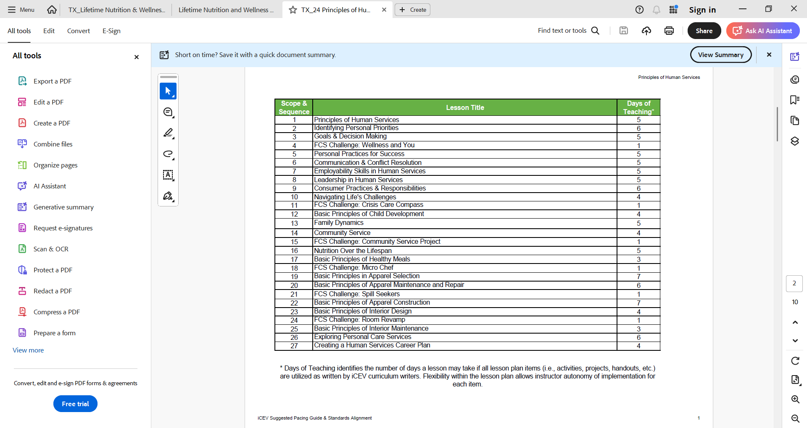

2nd Nine Weeks

3rd Nine weeks

4th Nine Weeks

North Zulch ISD
11390 Fifth Street
North Zulch, TX 77872

